Supplementary Table S1: Natural components of Nigella sativa seeds and oil
Compound | PubChem  CID | Molecular  Formula | Structure | Description
n-Nonane | 8141 | C9H20 | 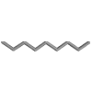 | It is a clear colorless liquid having sharp smell.
Tricyclene | 79035 | C₁₀H₁₆ | 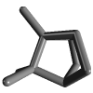 | It is a monoterpene.
Camphene | 6616 | C₁₀H₁₆ | 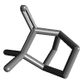 | It is a white to colorless crystalline solid with camphor like smell.
β-Pinene | 14896 | C₁₀H₁₆ | 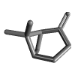 | It is part of many essential oils with exocyclic double bond and a plant metabolite.
Sabinene | 18818 | C₁₀H₁₆ | 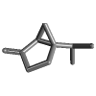 | It is a thujene and a plant metabolite.
Nigellicine | 11402337 | C₁₃H₁₄N₂O₃ | 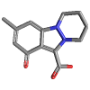 | It is an alkaloid and found in many spices and herbs.
Nigellidine | 136828302 | C₁₈H₁₈N₂O₂ | 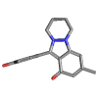 | It has indazole nucleus.
Nigellimine | 20725 | C₁₂H₁₃NO₂ | 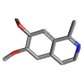 | It is found in many herbs and spices.
Carvacrol | 10364 | C₁₀H₁₄O | 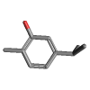 | It is a phenol and a derivative of monoterpene. It is a food additive and an inhibitor of bacterial growth.
Thymol | 6989 | C₁₀H₁₄O | 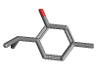 | It is a phenol and plays a role in volatile oil component.
Thymoquinone | 10281 | C₁₀H₁₂O₂ | 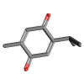 | It is found in many herbs and spices.
Dithymoquinone | 398941 | C₂₀H₂₄O₄ | 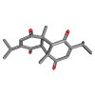 | It is anti-cancer and anti-diabetic.
Thymohydroquinone | 95779 | C₁₀H₁₄O₂ | 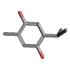 | It is helpful in treating asthma, cough, influenza, fever, dizziness etc.
Oleic acid | 445639 | C₁₈H₃₄O₂ | 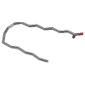 | It is a yellowish to colorless liquid which floats on water.
Palmitic acid | 985 | C₁₆H₃₂O₂ | 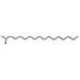 | It is found in palm oil, butter, cheese, milk, and meat.
Kaempferol | 5280863 | C₁₅H₁₀O₆ | 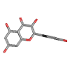 | It is an anti-oxidant and reducing oxidative stress. It is also anti-bacterial and plant metabolite.
Borneol | 64685 | C₁₀H₁₈O | 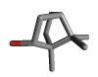 | It is a whitish lump solid having camphor like odor. It is used to make perfumes.
Linalool | 6549 | C₁₀H₁₈O | 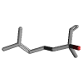 | It is a plant metabolite and anti-microbial agent
Terpinolene | 11463 | C₁₀H₁₆ | 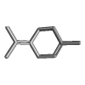 | It is used to make plastics and resins.
Limonene | 440917 | C₁₀H₁₆ | 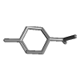 | It has a lemon like smell and a colorless liquid
α-Thujene | 17868 | C₁₀H₁₆ | 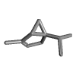 | It is a natural organic compound and present in many essential oils
Limonene oxide | 91496 | C₁₀H₁₆O | 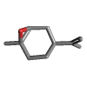 | It is a plant metabolite
α-Pinene | 440968 | C₁₀H₁₆ | 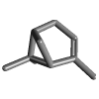 | It is used as a insect repellent and also in fragrance industry
Camphor | 2537 | C₁₀H₁₆O | 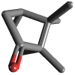 | It has same density as water and used to make moth proofing, flavorings and pharmaceuticals
Ledol | 92812 | C₁₅H₂₆O | 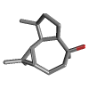 | It is for pain relief
Decanoic acid | 2969 | C₁₀H₂₀O₂ | 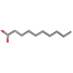 | It is used to make esters for perfumes and fruit flavors
Linoleic acid | 5280450 | C₁₈H₃₂O₂ | 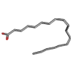 | It is found in many plant oils and used in biosynthesis of cell membrane
Myristic acid | 11005 | C₁₄H₂₈O₂ | 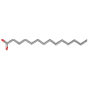 | It is a constituent of palm oil, butter oil and butter fat
Acetic acid | 176 | C₂H₄O₂ | 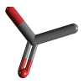 | It has anti-bacterial and anti-fungal properties
Valencene | 9855795 | C₁₅H₂₄ | 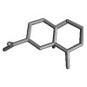 | It has anti-inflammatory and anti-allergy properties
4-terpineol | 11230 | C₁₀H₁₈O | 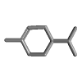 | It has anti-oxidant, anti-bacterial, anti-inflammatory, anti-parasitic properties. It is an apoptosis inducer
ρ-cymene | 7463 | C₁₀H₁₄ | 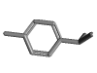 | It prevents cough and phlegm. It is used in fungicides and pesticides
t-butylhydroquinone | 16043 | C₁₀H₁₄O₂ | 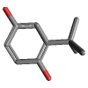 | It is a food additive and does not give discoloration in iron presence
Eicosadienoic acid | 6439848 | C₂₀H₃₆O₂ | 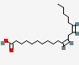 | It is a long chain fatty acid
Myristoleic acid | 5281119 | C₁₄H₂₆O₂ | 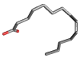 | It is a plant metabolite and an apoptosis inducer
Stearic acid | 5281 | C₁₈H₃₆O₂ | 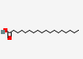 | It is found in many animal and plant fats and present in cocoa and shea butter
Thujadiene | 85582292 | C₁₀H₁₄ | 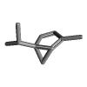 | It is a colorless to pale yellow liquid
Pinocarvone | 121719 | C₁₀H₁₄o | 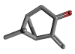 | It is a bridged compound made from rearrangement of carvone and has a role as mouse metabolite
Farnesol | 445070 | C₁₅H₂₆o | 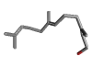 | It is a colorless liquid having delicate floral odor
Cyclohexane | 8078 | C₆H₁₂ | 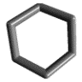 | It is a clear colorless liquid having petroleum like odor
Longifolene | 289151 | C₁₅H₂₄ | 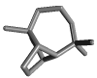 | It is a sesquiterpene
Ylangene | 6432119 | C₁₅H₂₄ | 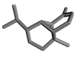 | It is a sesquiterpenoids, which is a class of organic compounds
3-Carene | 26049 | C₁₀H₁₆ | 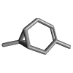 | It is a colorless liquid having sweet and turpentine like odor
Naphthalene | 931 | C₁₀H₈ | 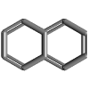 | It is a white, volatile, and polycyclic hydrocarbon with strong mothball odor
Caryophyllene | 5281515 | C₁₅H₂₄ | 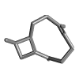 | It is a pale yellow oily liquid
Methyl Stearate | 8201 | C₁₉H₃₈ o | 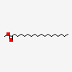 | It is a fatty acid methyl ester and have white crystals or chunky solid

Supplementary Table S2: Docking Score of Nigella sativa compounds with spike protein
No. | Compounds | Docking Score
1 | n-Nonane | -4.9746
2 | Tricyclene | -4.6558
3 | Camphene | -4.5584
4 | β-Pinene | -4.3128
5 | Sabinene | -4.6257
6 | Nigellicine | -5.5418
7 | Nigellidine | -5.9424
8 | Nigellimine | -5.3960
9 | Carvacrol | -4.9105
10 | Thymol | -4.8852
11 | Thymoquinone | -4.8633
12 | Dithymoquinone | -5.7371
13 | Thymohydroquinone | -5.0080
14 | Oleic acid | -7.0120
15 | Palmitic acid | -6.3564
16 | Kaempferol | -5.8171
17 | Borneol | -4.3367
18 | Linalool | -5.1225
19 | Terpinolene | -4.8497
20 | Limonene | -4.8588
21 | α-Thujene | -4.8781
22 | Limonene oxide | -4.8070
23 | α-Pinene | -4.3473
24 | Camphor | -4.2822
25 | Ledol | -5.1227
26 | Decanoic acid | -5.6697
27 | Linoleic acid | -6.9182
28 | Myristic acid | -6.2906
29 | Acetic acid | -3.5985
30 | Valencene | -4.8395
31 | 4-terpineol | -4.7617
32 | ρ-cymene | -4.6655
33 | t-butylhydroquinone | -4.7617
34 | Eicosadienoic acid | -7.4234
35 | Myristoleic acid | -6.4648
36 | Stearic acid | -7.0729
37 | Thujadiene | -4.7222
38 | Pinocarvone | -4.6306
39 | Farnesol | -6.1679
40 | Cyclohexan | -3.7914
41 | Longifolene | -4.8889
42 | Ylangene | -4.4748
43 | 3-Carene | -4.8296
44 | Naphthalene | -4.4270
45 | Caryophyllene | -4.9035
46 | Methyl Stearate | -7.4506

