Supplementary Data

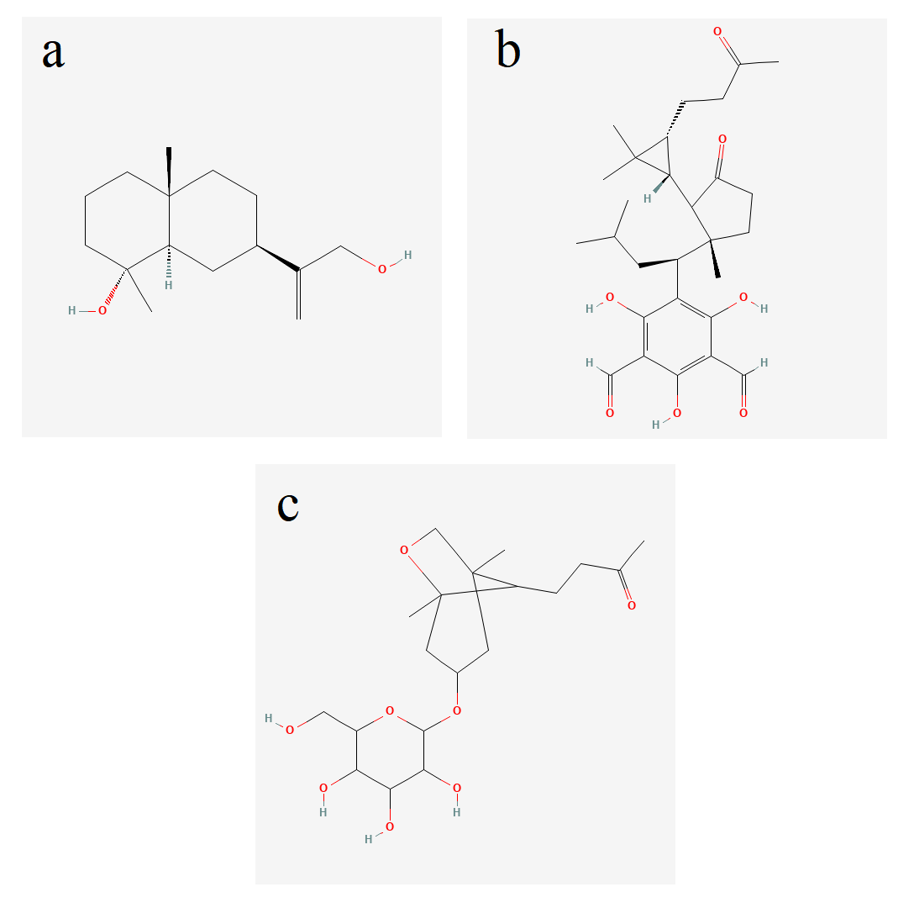
Figure S1: Chemical structures of a) eucalyptone b) ilicol c) ascleposide E
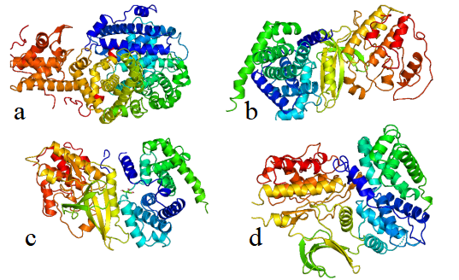
Figure S2: Crystal structures of G1/S regulatory proteins a) E2F-2, b) CDK4, c) Cyclin D1, d) CDK6

